Italian Cybersecurity Perimeter Compliance for Log360
Tagline: Support Italy’s Cybersecurity Perimeter compliance with continuous monitoring from Log360.

Overview
The Italian Cybersecurity Perimeter (DPCM 81/2021 + Law 133/2019) Compliance extension for Log360 supports Italian public bodies, operators of critical national networks, and strategic enterprises in fulfilling the security monitoring and incident reporting requirements of Italy's National Cybersecurity Perimeter.
Log360 ingests and correlates logs from critical systems, network infrastructure, cloud environments, and identity platforms, providing real-time visibility into events affecting perimeter assets. Security teams can rapidly detect incidents, perform forensic investigations, and produce the documentation required by ACN and CVCN oversight.

Key Features
- Generate compliance reports covering security monitoring events for perimeter-designated assets, aligned to DPCM 81/2021 requirements.
- Track access to critical systems, detect unauthorized changes, and identify anomalous user behavior across perimeter infrastructure in real time.
- Leverage preconfigured correlation rules to detect advanced threats and supply chain attacks targeting national cybersecurity perimeter assets.
- Export audit evidence in PDF and CSV formats to support ACN notifications and CVCN security assessments.



Screenshots
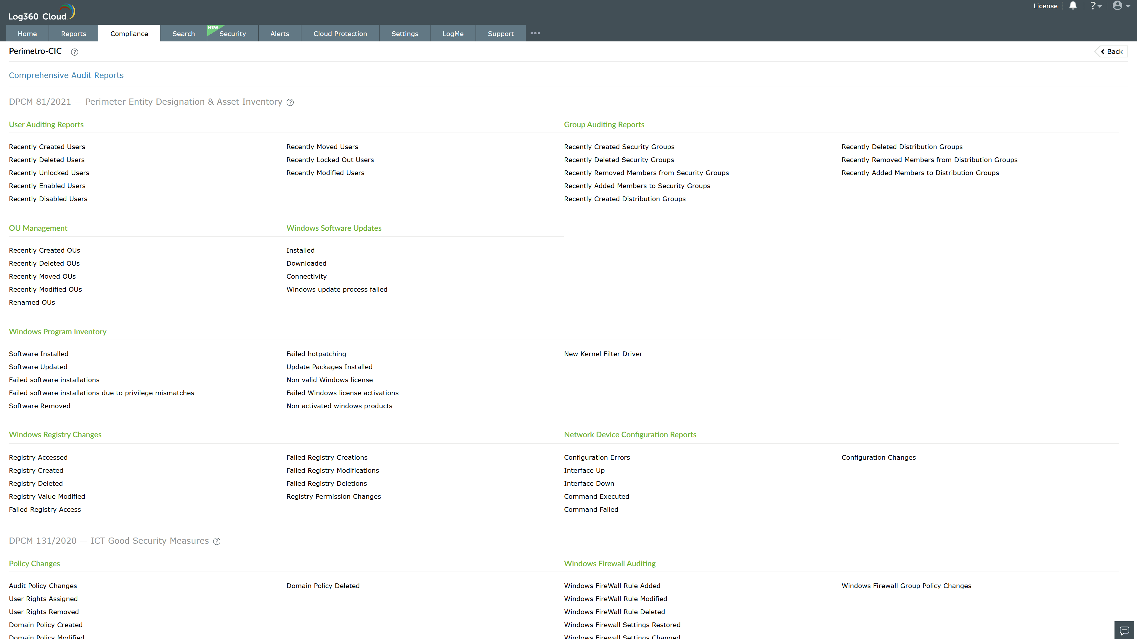
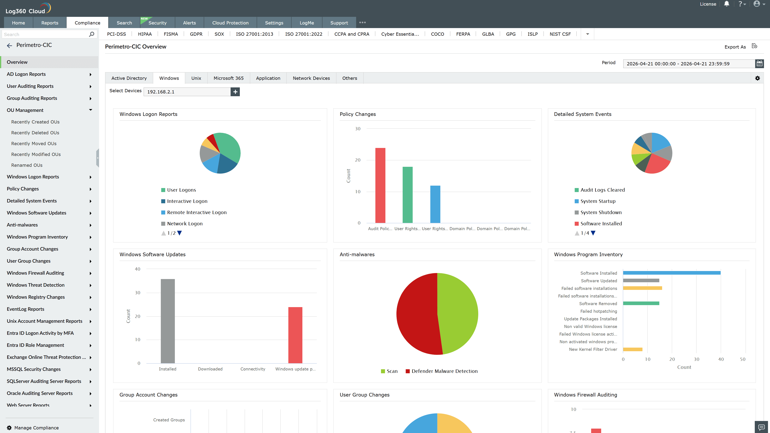
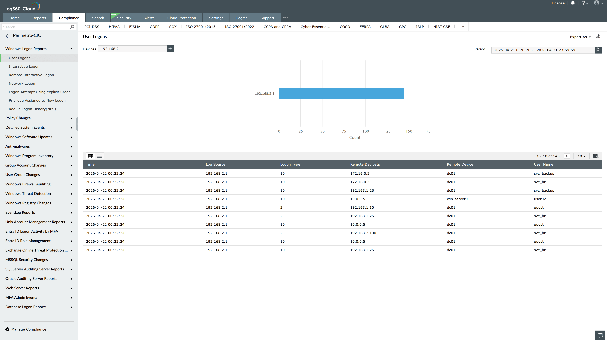
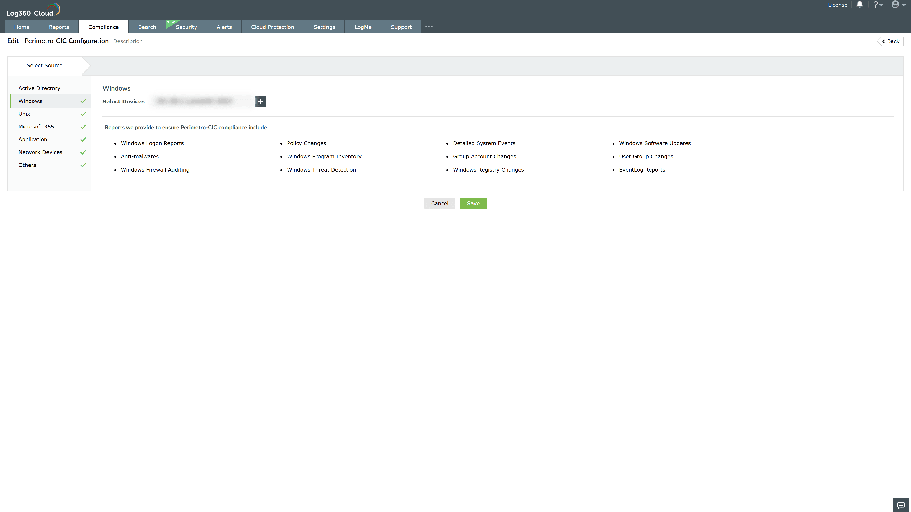

Valid Submission : Yes
Supported Editions : Free, Basic, Standard, Professional, MSSP
Help Document : https://www.manageengine.com/log-management/help/integrations/compliance-extensions.html
Help Video : Not provided
Tags : Log360, Compliance, Privacy monitoring, Data privacy, Regulatory compliance
Supported DCs : US, IN, JP, CA, AU, UK and EU
Privacy Policy:
Terms of Service:
Release Notes:
Predefined reports for the Italian Cybersecurity Perimeter (DPCM 81/2021 + Law 133/2019) Compliance

